Assignment on Rivets

**Question 1:**

Two plates, each 15 mm thick and carrying an axial load of 175 kN, are connected by means of double-strap butt joint as shown in Fig. 1. Assume that rivets in double shear are 1.875 times stronger than in single shear. The permissible stresses for rivets and plates in tension, shear and compression are 80, 60 and 120 MPa respectively. Calculate:

(i) diameter of the rivets; and

(ii) width of the plate.

Assuming the above values, calculate:

(iii) strength of the joint if failure is to occur along the section-*AA*;

(iv) strength of the joint if failure is to occur along the section-*BB*;

(v) strength of the joint if failure is to occur along the section-*CC*;

(vi) strength of the joint if the failure is to occur due to shearing of rivets;

(vii) strength of the joint if the failure is to occur due to crushing of rivets;

(viii) strength of solid plate; and

(ix) efficiency of the joint.

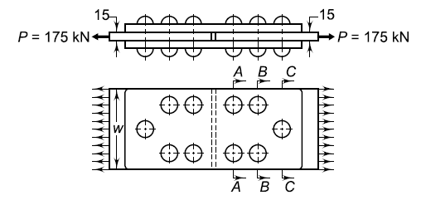

**Question 2:**

A pressure vessel of the boiler consists of cylindrical shell of 0.8 m inner diameter. It is subjected to internal steam pressure of 2 MPa. Triple-riveted double-strap longitudinal butt joint is used to make the shell. The straps are of unequal width. The pitch of the rivets in outer row is twice of the pitch of rivets in middle and inner rows. A zig-zag pattern is used for arrangement of rivets. The efficiency of the joint should be at least 80%. The corrosion allowance is 2 mm.

The permissible stresses for rivets and shell in tension, shear and compression are 80, 60 and 120 MPa

respectively.

Calculate:

(i) thickness of the shell;

(ii) diameter of the rivets;

(iii) pitch of the rivets in outer row;

(iv) distance between outer and middle rows;

(v) distance between middle and inner rows;

(vi) thickness of inner strap;

(vii) thickness of outer strap; and

(viii) efficiency of the joint.

**Question 3:**

A bracket is attached to a horizontal column by means of three identical rivets as shown in Fig. 2. The maximum permissible shear stress for the rivets is 60 MPa.

(i) Which rivet is subjected to maximum shear force?

(ii) What is the magnitude of maximum force?

(iii) Determine the diameter of rivet.

